Activity No. 1.3
Writing First Program using C++ Language
Course Code: CPE010 | Program: Computer Engineering
Course Title: Data Structures and Algorithms | Date Performed: 9/1/25
Section: CPE11S1 | Date Submitted: 9/1/25
Name(s): Paula Esguerra | Instructor: Engr. Jimlord Quejado
6. Output
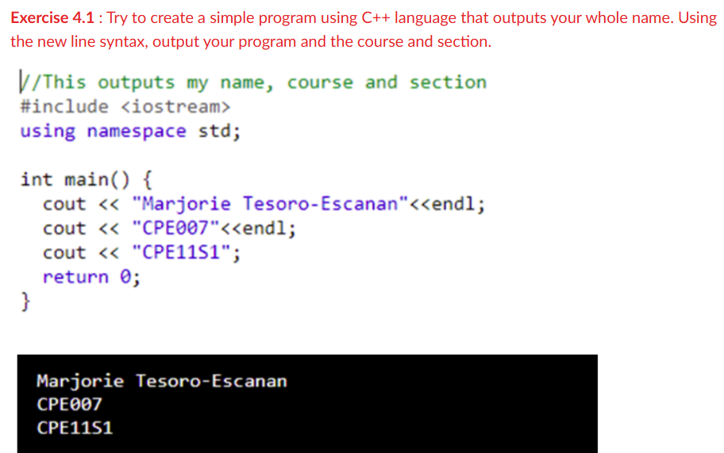

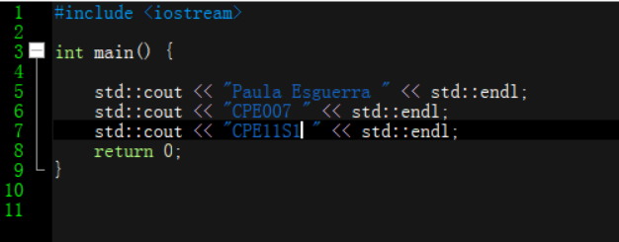
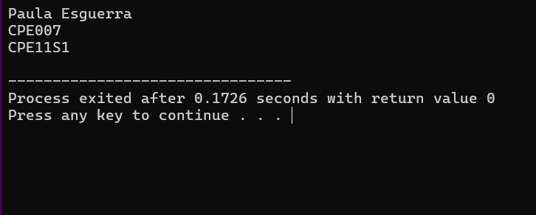

Start
Input Name
Input Subject
Input Section
Return 0

End

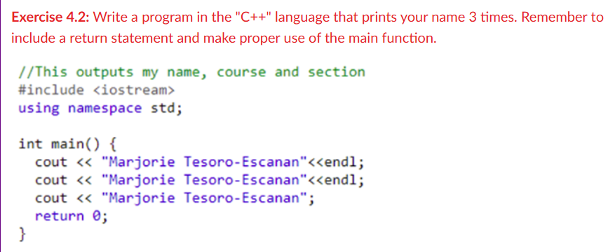

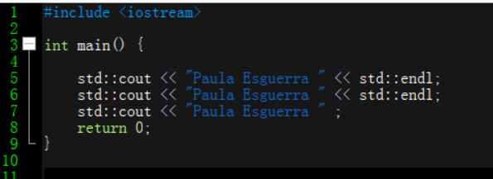
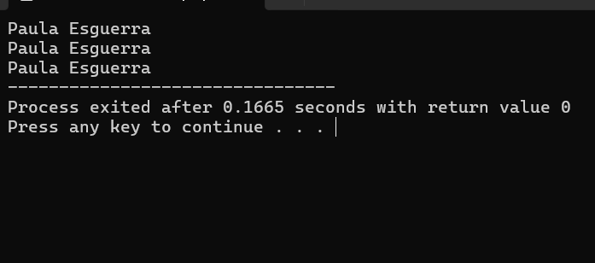
Start
Input Name
Input Name
Input Name
Return 0

End

7. Supplementary Activity
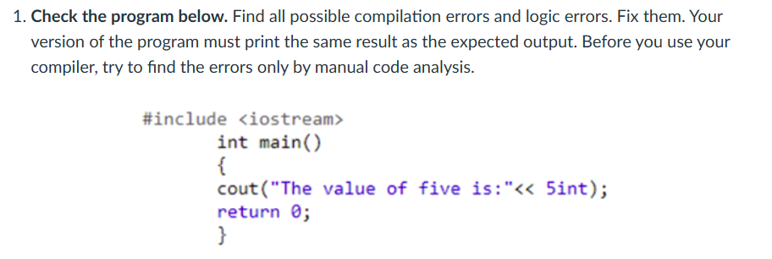
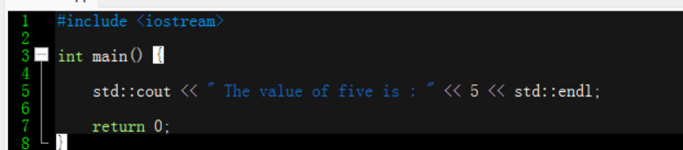
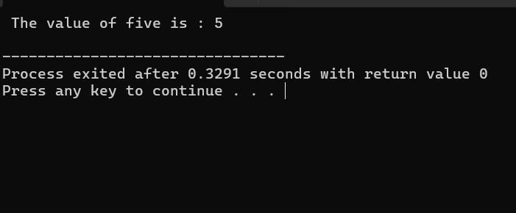

Start
Input “ The value of five is :”
Input 5
Return 0
End
The error was you have to remove “int” it isn’t needed in the program, also, it lacks “std”” “ after cout, since it doesn’t have namespace, you have to manually put std in every start and ending. And then, the parenthesis is inappropriate, it isn’t need to get the output.

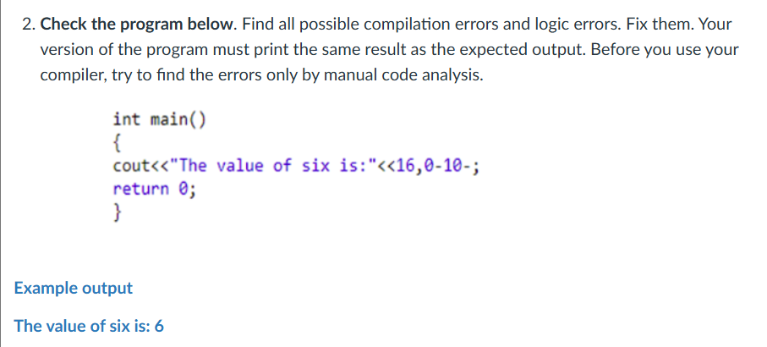

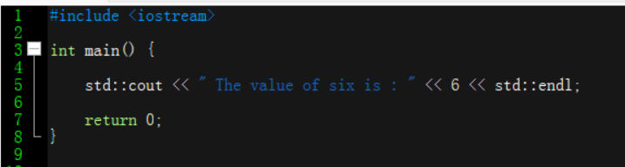
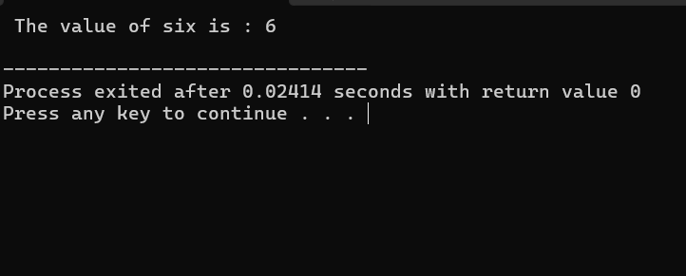

Start
Input “ The value of six is:”
Input 6
Return 0
End

The error was to have the input 6, you need to remove “16, 0-10-“ and replace 6. Then “std::” is needed after cout, since namespace isn’t put.

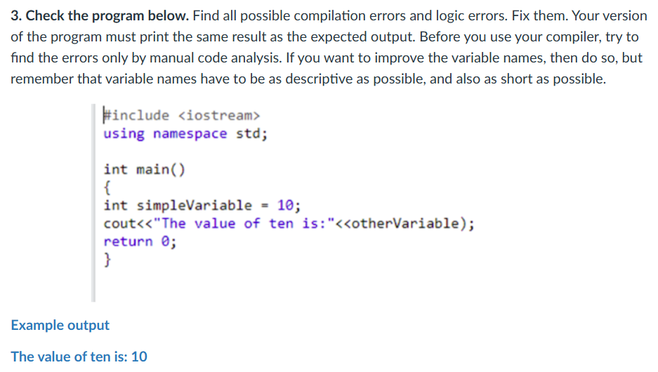

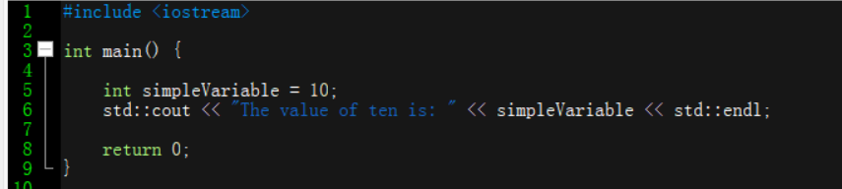
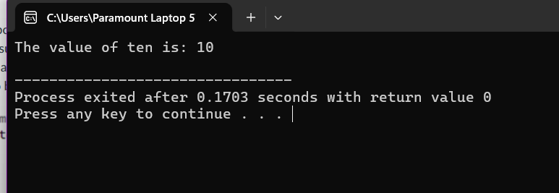

Start
Input “simpleVariable”
Set to 10
Input “ The value of ten is:”
Return 0
End

The error was the variable name is incorrect, so change it to simpleVariable for the program to execute 10 as the output.

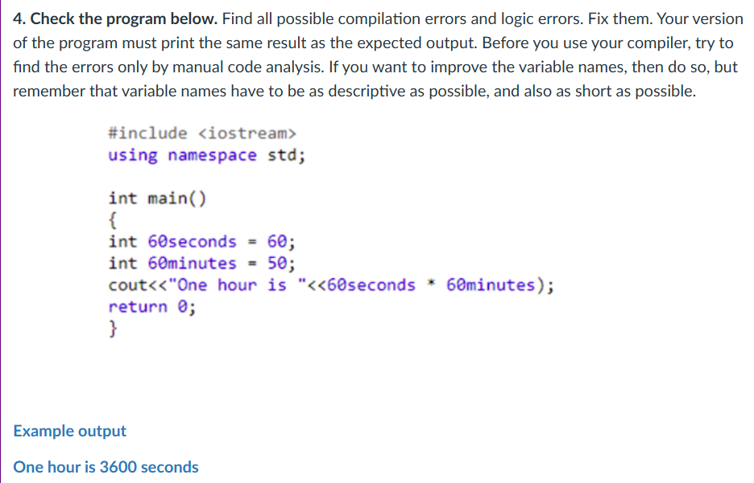

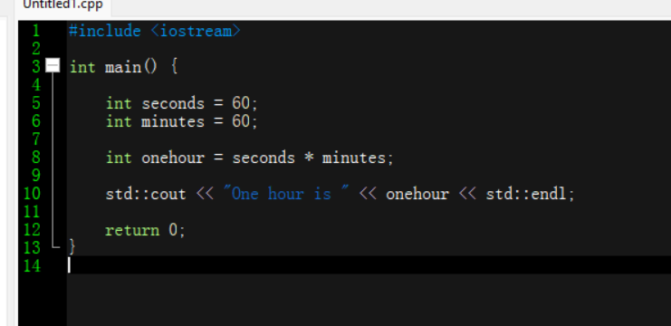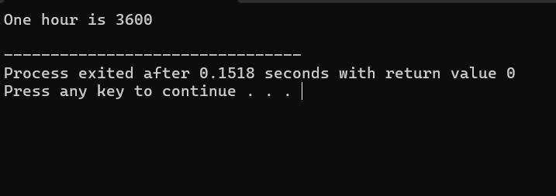
Start
Input “seconds ”
Set to 60
Input “minutes”
Set to 60
Input “onehour = seconds * minutes”
Input “one hour is”
Return 0
End

The error was in the rules of integers, words are only accepted, so remove the numbers, then change the set number of minutes into 60 to have the output as 3600 when it is multiplied. Remove “seconds multiplied to minutes” in the cout lane, put it it before the cout and add an integer before it. The parenthesis isn’t needed.

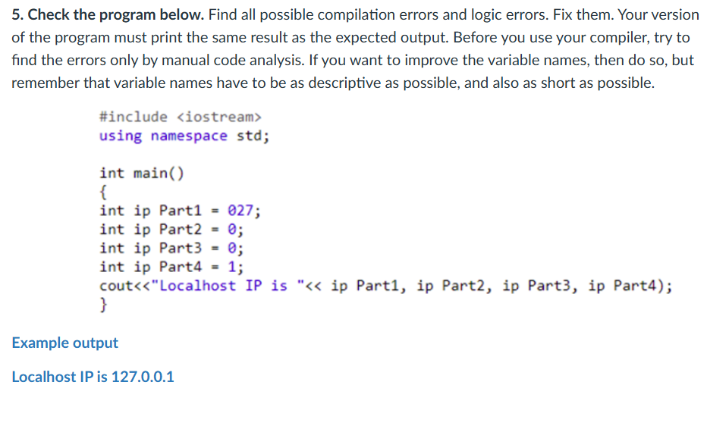
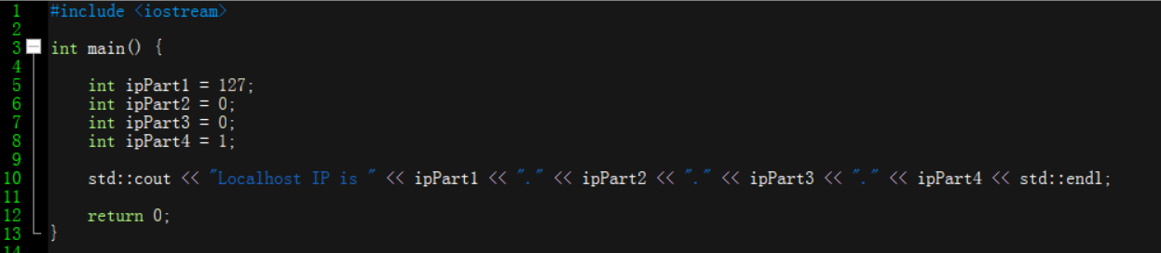
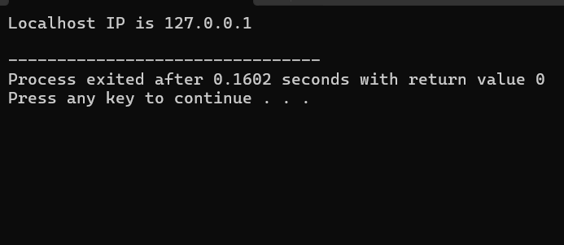

Start
Input ipPart1
Set to 127
Input ipPart2
Set to 0
Input ipPart3
Set to 0
Input ipPart4
Set to 1
Input “Localhost IP is”
Return 0
End

The error was I considered removing the space between ip and part, so it would be considered a title/name. Then, to have the 127 as the output, you have to change 027 to 127. And to have the decimal in between, you better add “.” In between the titles.

9. Assessment Rubric

